Metro Anime Summer 2010 Survey – Quick Cheat Sheet

- Senkou no Night Raid - Just before WWII, an elite squad of international agents with unusual abilities carries out undercover missions on behalf of Japan in turbulent Shanghai. As their missions become ever more morally ambiguous and their loyalties are constantly tested, the squad questions whether they're fighting for the right reasons, and for the right side. Mixing historical events with clandestine spy-vs-spy activities, Night Raid offers a supernatural alt-history version of "Mission: Impossible", Shanghai-style. [13 eps]

- Mushishi - In a dream-like vision of pre-war Japan, a lone man travels the countryside in search of 'mushi' - tiny, primitive creatures caught between flesh and spirit. As a mushi doctor, Ginko helps people caught in the mushi's web of delusion, delight and despair, but can he help himself? Beautifully styled, with haunting music and compelling stories that really pull you into the richly-nuanced world of the mushi. [26 eps]


- Kaichou wa Maid-sama - Misaki runs her school with an iron fist of discipline, as the newly-elected student body president of a rough boys' school that recently went co-ed. Her attempts to remake the school as a paradigm of girl-friendly, well-mannered behavior cause lots of friction and arouse the suspicion of Usui, the "lone wolf" de-facto leader of the boys. Usui discovers Misaki's frilly little secret - she's making ends meet at home by working at a maid cosplay cafe! Will Misaki kill Usui to keep her secret, or will she go postal on the maid cafe's stalker-ish patrons first? [26 eps]
- Kimi ni Todoke - A refreshingly innocent love story of a painfully shy girl who discovers friendship, first love, and happiness after years of being reviled and ostracized by her classmates and teachers. Blossoming like a flower in the sun, Sawako (who looks like “Sadako” - the ghost-girl from “The Ring”) speaks to the awkward adolescent that everyone used to be, and brings a new attitude to familiar coming-of-age territory. [25 eps]
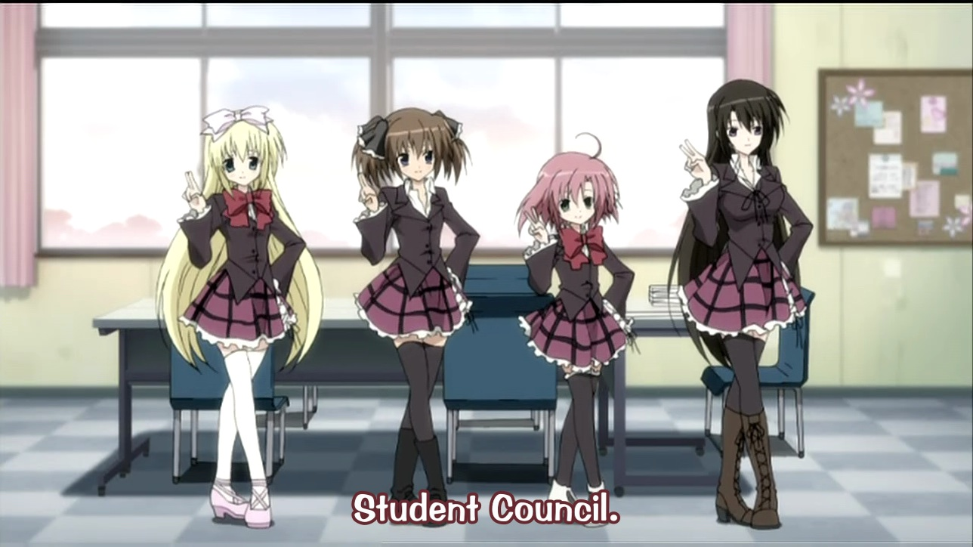
- Seitokai no Ichizon - A comedy series about the misadventures of a "do-nothing" high school student council whose members are anything but typical. The adorably chibi President has a head full of determination, but little else, while the cool VP moonlights as a corporate raider. Leading the antics is Ken, a would-be Casanova, trained only by ero-games, whose absurd harem-fantasies shield a wounded heart. Packed with parodies, the show takes playful aim at everything from Death Note to Haruhi Suzumiya, with plenty of sight gags, snappy comebacks, and over-the-top situations surrounding its loose plot. [12 eps]
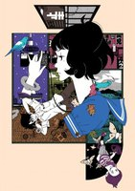
- The Tatami Galaxy - Fascinating, fast-paced, and completely twisted, The Tatami Galaxy takes us on a surreal trip into the "Twilight Zone" version of a young man's college life. Caught out of time, our hero repeatedly plays out his experiences pursuing the girl of his dreams, Akashi, only to fall prey to the demonic temptations of his frenemy, Ozu. Every cycle begins with the prophetic choice of which school club to join, and ends with a choice between good (Akashi), and evil (Ozu). But will he decipher the riddle of the gods and break the curse? Even if he doesn't, it's ridiculously fun to watch... [11 eps]

