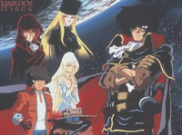
METRO ANIME PRESENTS
Welcome To The Leijiverse Festival!
Event Host:
Shawn Raymond Singleton

12:00 PM-6:00PM
Sunday June 27, 2010
Maui Tacos
330 Fifth Ave
Between 32nd & 33rd Streets
New York, New York 10018
[$3.00 cover charge venue fee]

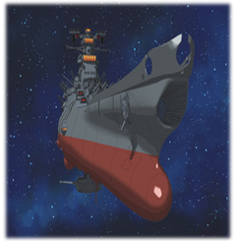
Space Battleship Yamato (Star Blazers):
The human race is in a life or death struggle against alien invaders called the Gamilas. Sadly, mankind is losing the war against this threat. Besides being outmatched by the Gamilas’ fleet, Earth itself is also under siege by their radioactive meteorite that have contaminated the whole planet and forced people to live underground. The only hope is for humanity is to retrieve the “Cosmo-Cleaner D” from planet Iscandar that will cleanse the Earth. It’s up to the motley crew of Yamato to obtain the “Cosmo-Cleaner D” within one year or the human race will cease to exist.

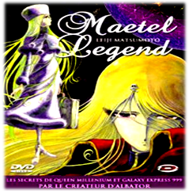
Maetel Legend:
Go back to where the saga began. This foray into the Galaxy Express 999 universe starts with the origins of Maetel, Emeraldas and Millennia. Maetel becomes the maiden traveler who holds the hopes of man’s dreams. Emeraldas becomes the pirate queen of space who rivals Captain Harlock. Queen Millennia is the mother of the twins Maetel & Emeraldas and ruler of Great Andromeda. She becomes Queen Prometheum of the mechanized empire, and thus begins the war with the humans of Earth.

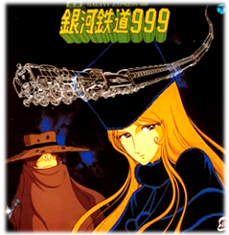
Galaxy Express 999:
Tetsuro Hoshino is just another urchin from Earth until he meets a mysterious, beautiful stranger who travels through space and bears an eerie resemblance to his late mother. She offers him free passage on the Galaxy Express 999 on the condition that she travels with him. Tetsuro sets out on a journey of adventure and self-discovery to manhood. He longs for a mechanized body and revenge against his mother’s killer. And what is the mysterious, beautiful stranger’s true motive and her plan for Tetsuro?

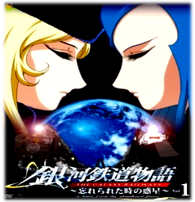
Galaxy Railways OVA:
The Galaxy Express 999 saga continues in this OVA epic. Set some time after the original story, space has become the travel, vacation, & exploration frontier of mankind, thanks to an intergalatic travel network known as the Galaxy Railways, inspired by the first train, Galaxy Express 999. The Galaxy Railways are heavily guarded by the advanced military force known as the S.D.F. The Sirius Platoon of the S.D.F. is dispatched to a forbidden planet last visited years ago by the Galaxy Express 999. What is the history that connects Galaxy Express 999 and this forbidden planet? We will also see the return of some old favorites.

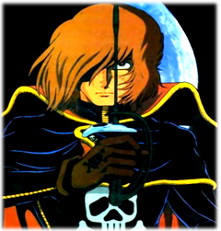
Captain Harlock:
The human race stands on the brink of being conquered by unforseen invaders. Thanks to inept, callous, and greedy world government, mankind’s only hope for preservation is an intergalactic outlaw who represents the best of the human race. Captain Harlock and his crew of the Arcadia are space pirates working for a true democratic republic, and are out to save the world—if the world government doesn’t capture them first.

