Rumiko Takahashi Fest



When: Sunday March 27, 2011

Where: Maui Tacos
330 Fifth Ave. btw W. 32nd & W. 33rd Streets

Time: 12:00 noon ~ 6:00 PM

Urusei Yatsura is the story of the unluckiest and most lecherous young man alive, Ataru Moroboshi. When aliens decide to invade Earth, Ataru is randomly selected to defend his planet by playing a game of the aliens’ national sport, tag. Should he win, the world shall be saved. However, Ataru is motivated for far less noble reasons, as the one he plays against is revealed to be the curvaceous alien princess, Lum.

InuYasha
Higurashi Kagome, after being pulled down a well by a demon, finds herself in feudal Japan, where she learns that a powerful jewel has been reborn inside her body. After the jewel shatters in an attempt to retrieve it from one of the many demons who was after its power, Kagome must join forces with the half-demon InuYasha (also after the jewel’s power) to track down the shards of the jewel before its power falls into the wrong hands.
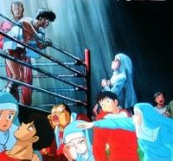
One-Pound Gospel
Kosaku Hatanaka is a natural at boxing, but he can’t control his voracious appetite. Kosaku eats anything and everything. As a result, his weight goes up, and he is forced to fight in heftier weight class bouts. Sister Angela is a young novice nun who feels for Kosaku. She encourages him, and does whatever she can to make sure Kosaku is in shape.

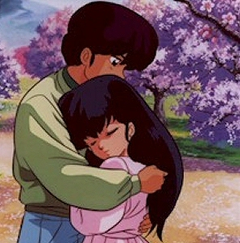
Maison Ikkoku
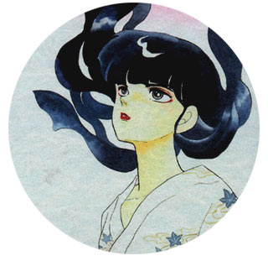
Godai is a rōnin (someone who has failed university entrance exams) living in a run down apartment house called Maison Ikkoku. Among the other residents are the nosy Ichinose, the sexy Akemi Roppongi, and the mysterious Yotsuya. The others are given to having wild parties which makes it difficult for Godai to study. Into this mayhem comes the recently widowed Kyōko as the new live-in manager. Godai falls for her, but doesn't have the nerve to tell her. As time passes, their relationship slowly develops amid life at Maison Ikkoku, despite all sorts of romantic hurdles.

Mermaid Forest
Legend states that eating the flesh of a mermaid will bestow immortality. Yuta and Mana do not remain dead for this reason. Unfortunately, mermaid's flesh affects people differently. Trying to help her sister Towa, Sawa creates a problem that will affect both of them for the rest of their lives. And now Towa's plans threaten both Yuta and Mana.

Ranma ½
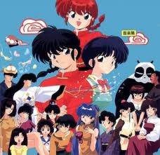
Saotome Ranma, a teenage martial artist, and his father Genma travel to the ‘cursed training ground’ of Jusenkyō in China. There, despite the warnings of the Chinese guard, they fall into the cursed springs. From now on, whenever Ranma is doused in cold water, he turns in to a girl, and a cute, well-built red-head at that. Hot water changes him back into a man again, but only until the next time. To make matters worse, his father engages him to Tendō Akane, a girl who hates boys.

